|  |  |
| --- | --- |
| Legal Aid Agency |  |
|  |

1 September 2015

Dear Colleague

**Re: Crown Court Coverage**

As you know, the LAA established a Crown Court Representation helpline to help clients to obtain legal advice.

Given that the profession’s strike action has now concluded, this helpline has now been closed down.

I wanted to thank you for your agreement to be included as a source for clients to contact.

Your assistance was much appreciated and helped us maintain services to vulnerable clients.

Yours sincerely

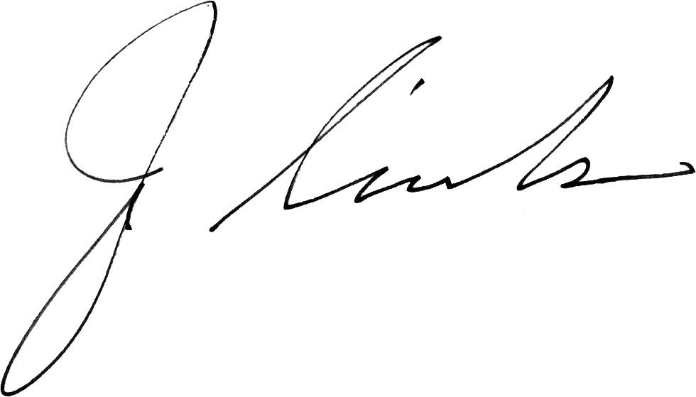

**JOHN SIRODCAR**

**HEAD OF CONTRACT MANAGEMENT**