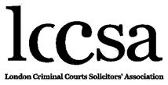
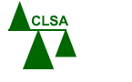
27th March 2020

A Joint Message from the LCCSA & CLSA
Police Station & Magistrates’ Court Attendance

Further to the publication on 26th March 2020 of a joint Message from the LCCSA & CLSA
on Police Station & Magistrates’ Court attendance, the undersigned firms hereby support
this Message:

Powell Spencer & Partners Bullivant Law
Edward Fail, Bradshaw and Waterson Hodge Jones & Allen Solicitors
BSB Solicitors ABV Solicitors
Birnberg Peirce Birds Solicitors
Edwards Duthie Shamash Clarke Kiernan LLP
Imran Khan & Partners Lewis Nedas Law
Traymans Solicitors GT Stewart Solicitors
Commons Bindmans LLP
Shaw Graham Kersh Solicitors Tuckers Solicitors
MK Law Solicitors Blackfords LLP
Galbraith Branley Solicitors

V1

