**NORTH LONDON BAR MESS**

**Golden times at Snaresbrook!**

**The NLBM and the Judges of Snaresbrook Crown Court invite you to celebrate the 50th anniversary of Snaresbrook Crown Court!**



**21November 2024**

**5-8pm**

**Snaresbrook Crown Court**

**TICKETS**

**Free for members who set up standing order for annual £20 membership before Friday 8 November 2024.**

**Non – members: £20 each before Friday 8 November 2024. £25 thereafter.**

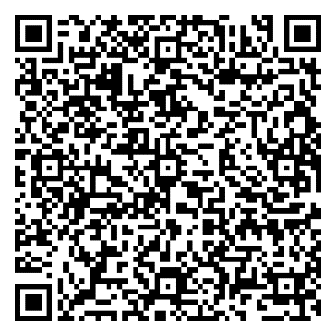

To join, scan:

**BENCH AND BAR BOTH WELCOME**