 |  |  | Joanne Towens  Delivery Director, London Crime  Michelle Penn,  Delivery Director, Royal Courts of Justice Group  HMCTS
 |  |  | 17th February 2026
Dear justice partner,

I am writing to provide you with an update on the City of London Law Courts development.

Construction of the 18-room courthouse continues to progress well, and we recently celebrated a significant milestone by marking the topping out – the highest point the building will reach. We anticipate that the building will open in the Spring of 2027.

We are pleased to confirm that the senior judiciary have agreed that mainly heavy fraud work, that is currently heard at Southwark Crown Court, will be heard in the new City of London Crown Courts. Other work will need to be listed, to ensure we fully utilise both the courts at Southwark and the City of London law Courts. Senior Judiciary led by the DSPJ are finalising the details.

We continue to work closely with the judiciary to determine the types of civil cases that will be heard at the new courthouse, including the relocation of case types currently heard at the Mayor's and City of London County Court. We are also in discussions regarding the listing of magistrates' court cases.

To ensure the new courthouse serves your needs effectively, we will be launching a consultation with court users in the coming months. This will help us better understand your requirements and will inform our planning in key areas such as IT infrastructure and facilities. I will contact you in due course with full details of how you can participate in this consultation.

In the meantime, should you have any questions about this development, please contact our Operational Project Manager, Jim Doherty, jim.doherty@justice.gov.uk

Thank you for your continued interest in this important project.

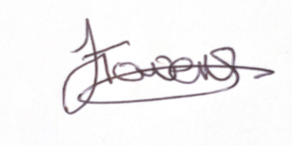

Joanne Towens Michelle Penn
Delivery Director – London Crime Delivery Director – RCJ Group

